

**FACULTY OF COMPUTING**

**INDUSTRIAL TRANING REPORT**

BY

MARY CHEW JIA YI

2020

BACHELOR OF SOFTWARE ENGINEERING

TRAINING PLACE : DHL IT SERVICES

TRAINING PERIOD : 1ST MARCH 2020 – 28th AUGUST 2020

ORGANISATION SUPERVISOR : LIM SING CHEK

FACULTY SUPERVISOR : MDM ERLIDA

Chapter 1

1.1 Organization Background

Deutsche Post DHL (DPDHL) Group is one of the most leading logistics companies in the world. It provides an international service portfolio that consists of letter and parcel dispatch, express delivery, freight transport, supply chain management as well as e-commerce solutions. It employs approximately 550,000 people in over 220 countries and territories worldwide. It comprises of different corporate divisions such as Supply Chain, Post & Parcel Germany, Express, eCommerce Solutions, Information Technology Services as well as Global Forwarding, Freight. The main focus in this report is the Information Services corporate division that I joined for my internship programme.

Information Technology Services (IT Services) is one of the largest service lines of the Global Business Services (GBS) division. It consists of more than 3,000 people serving the business units of DPDHL Group across Europe, Americas and Asia Pacific. IT solutions are crucial as DPDHL is highly relying on them such as integrated applications and high-performance systems to support the Group’s business. The main purpose of IT Services is to increase IT efficiency, leverage a world-class infrastructure, provide transparent and defined globally and support global expansion.

DHL IT Services companies are available in some locations of Europe, Americas and Asia Pacific. And one of them is located in Cyberjaya, Selangor, Malaysia that I was working in.

<https://www.dpdhl.com/en/about-us/corporate-divisions/it-services.html>

1.2 Vision and Mission

The vision is, IT Services is the Business Technology Partner of Choice for the Divisions of DPDHL.

The mission is we transform technologies into value for DPDHL Group through:

* Leveraging synergies across DPDHL Group Divisions
* Focusing our capabilities on our customers’ needs
* Optimizing integrated and lean processes

and we rely on our people’s IT expertise and their in-depth DPDHL Group and logistics industry knowledge.

1.3 Department/Division/Team

The department where I worked in is Solution Delivery where we build solutions and deliver them as products/services to meet the requirements of DPDHL. I was assigned to a division which was supervised by my line manager, Lim Sing Chek and there are 16 members in my team which comprises of project manager, software engineers, consulting analysts, Power BI consultants as well as test managers.

1.4 Customers and products

We handle different projects and each of them is assigned to different small teams of different technology knowledge within our division, such projects are BPMS, Azure Campbell, SLM, Sharepoint User Experience (SPuX) and others. Each of us has different technological knowledge background such as Javascript, Python, Java in different fields like web development, machine learning, business intelligence and others. Our customers are internal customers from different teams within DPDHL and we deliver products to meet their requirements.

Chapter 2

Involvement during the industrial training

2.1 Overview

Since the first day of joining my team in DHL IT Services, I have learned a lot in all the projects that I am involved in. Before I started to work on projects, I was involved in orientation which was the onboarding program for new employees on the first day of my internship programme. During the orientation, I learned important values from different sessions like talks and team-building games. Communication and teamwork are the important values when it comes to working in a team which comprises of several roles like manager, project managers, developers as well as testers to deliver good quality of services or products.

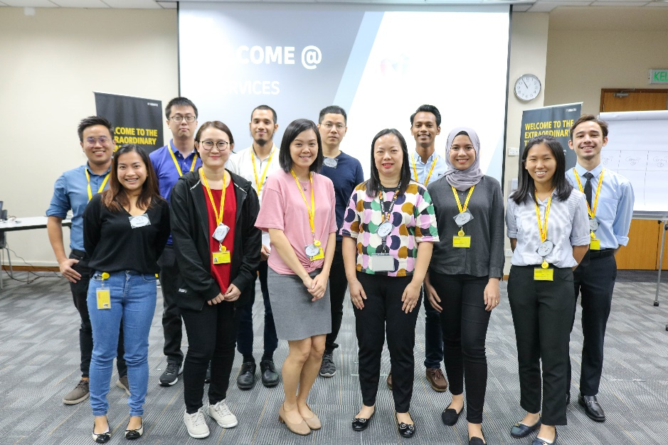

Figure 2.1 Group photo of new March joiners during onboarding program

Before I was assigned to real big projects from internal customers, my line manager, also known as my supervisor assigned me some tasks of existing projects as “practice” so I can adapt myself in future projects. She also got me a senior from my team which he can guide me to get familiar with how the existing project worked. Gradually, she assigned me with other projects for me to work on.

During my 6 months of internship, not only I was assigned to different tasks to accomplish them, but I was able to provide guidance to my team members on the projects that they stumbled upon, when it comes to coding. Besides that, I was given opportunities to do presentation on the project updates to my team, and I learned to present and give my own opinions to my team whenever we had meeting together. Besides coding, I was assigned to prepare release notes to record down the fixes and feature enhancement before deploying the code changes to the web production environment.

Besides working on projects, there were online learning conference call biweekly, which was called ITS Learning Friday that gathers employees from different countries to learn together on certain subject. I also took a 1-week of Microsoft Azure online training which we had access to the speaker’s notes and presentation slides as well as the on-hands lab training with free trial of Azure account.

2.2 Projects / Tasks

The projects that I was assigned to are web projects that use HTML, CSS, JavaScript as main languages, jQuery and Bootstrap as the main technologies, and SharePoint as the main configuration site that stores all the data.

2.2.1 SPuX

Sharepoint User Experience, abbreviated as SPuX is a website template that uses SharePoint that acts as “database” to configure the data and display it in the website. There are other customer websites that uses SPuX as main template to show the required information. All the data is configurable and dynamic in SharePoint lists. It means that different customer owns a website that uses SPuX template and they configure their own data in SharePoint for their purpose. Such customers are SLM, finance-support and Software Reuse.

This is the first project that I was assigned to, which I took my time to understand how SharePoint works, perform some fixes on the bugs and errors, as well as to enhance existing features and implement new features into SPuX. All the code changes were needed to be deployed to other customer sites as mentioned.

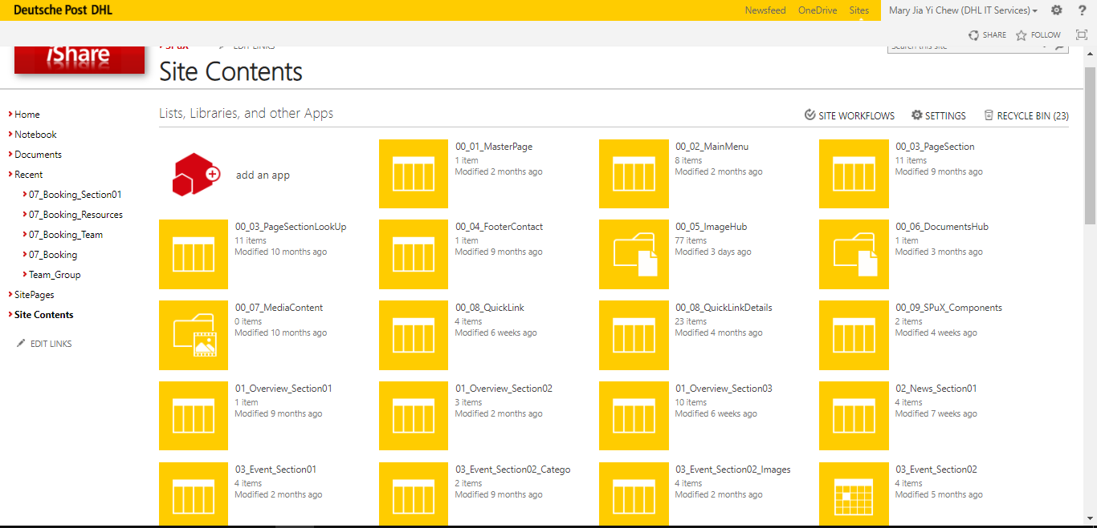

Figure 2.2 SharePoint list

2.2.2 Software Reuse

Software Reuse is one of the main goals to be reached in Solution Delivery Goals in 2020. It is an important initiative that helps developers to reuse existing components or codes from the Github, which comprises of different technologies and programming languages that helps developers to reuse what they need instead of doing the same component from scratch. Software Reuse is the latest customer that bought the SPuX template, so there were 2 teams working together to develop Software Reuse alongside with a few developers from Chennai, India.

Before launching Software Reuse, I was assigned to complete the PoC (Proof of Concept) within 2 weeks in order to present to the upper management for approval. The good news was the PoC was approved and we all proceeded to the real development of Software Reuse at first stage (Sprint 1) within 3 weeks and launched it after. However, the development did not stop at the Sprint 1, it continued to include more enhancement and fix error issues. We made use of SharePoint Rest API and Github API in order to build the web portal.

Here are some functions of Software Reuse:

* To list all the repositories of Software Reuse from SharePoint list
* To like and comment for the particular Software Reuse
* To list all the contributors of Software Reuse, feedbacks and discussion forum
* To view particular contributor’s information and follow him/her
* To apply to be a contributor
* To submit feedback
* To sync all the required data from Github to SharePoint

2.2.3 SPuX Calendar

Calendar is the latest feature in SPuX website. The reason of this latest amendment is that the management of DHL in Cyberjaya has allowed employees to go back to office to work voluntarily, however not all seats are available for use. Hence, the importance of calendar is to allow employees to book available seats based on their team, which depends on the date and time they book the seat.

I was assigned to develop seat booking calendar feature in SPuX within 3 weeks, and I had online meeting with my team members (Chek Lim, Phyllis Siaw and Michael Lin) that happened a few days within a week. During the meeting, I presented the progress update of the calendar to my team, and all of us brought up some ideas to improve the calendar feature.

Here are some functions of the seat calendar booking feature:

* Allow user to book a seat for themselves on any date and time
* Allow user to book a seat on behalf of team members on any date and time
* Allow user to edit, delete and view his/her bookings
* Allow user to oversee all the bookings and filter them based on date, time, seat, and team member’s name
* Allow user to view the seats map
* Allow user to verify the existence of team member

To develop the calendar feature, here are some tools that I used:

* SharePoint (To configure data, store data and provide API)
* FullCalendar (A plugin that provides calendar feature)
* DataTable (A plugin to generate table)

2.3 Experiences, Skills and Knowledge Gained

I went to office for a week before MCO started. I did not have to chance to meet all my team members but a few during week 1 of my internship as some of them had already started to work from home. I started to work from home since week 2 until the end of my internship. Nevertheless, I found myself to adapt this new normal easily when working from home. There are some pros and cons of working from home. The working hours were flexible and I could take several short breaks in between as it was advisable for us to stay hydrated and take some short breaks in between instead of staring at the laptop for the entire day. However, I experienced slow and unstable Internet connection during my work. I used mobile data hotspot instead of WiFi. The worst experience I had was when I faced Internet connection issue during my meetings with my team. In the middle of the meetings, my audio was breaking, not able to watch the presentation, heard breaking audio from my team, my team could not hear me properly and even got disconnected which I needed to sign in back and rejoin the meetings. Besides, I got frustrated when I was not able to connect to the server when I worked on some projects. I waited for a while for Internet connection to be stable again, and I found that it was a waste of time that it interrupted my work. To get better Internet connection, I went to MaGIC for work sometimes.